Algebra 1R – Mr. Bo Name:______________________________

Unit 4 – Day 1 Notes Date:______________

**Sequences**

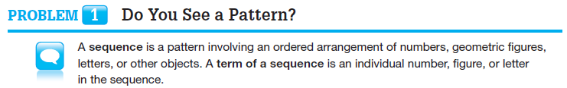

1. **Troop of Triangles**





2. **Al’s Omelets**

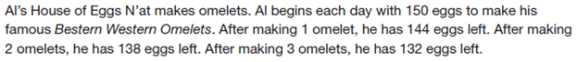









C:\Users\abo\Desktop\Algebra 1R\Icons\Discussion.jpg

1. Does the Troop of Triangles example represent an infinite or finite sequence? Explain.

2. Does the Al’s Omelets example represent an infinite or finite sequence? Explain.

**Arithmetic Sequences:**

C:\Users\abo\Desktop\Algebra 1R\Icons\Discussion.jpg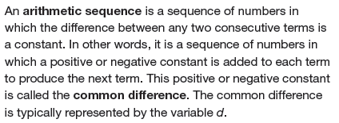

1. The sequence 3, 7, 11, 15… is arithmetic. What is the constant difference, d?

2. The sequence above can be described by the function: .

a. What does the variable n represent in the sequence?

b. What does the variable a(n) represent in the sequence?

3. Use the function a(n) to complete the table and plot the points on the graph.

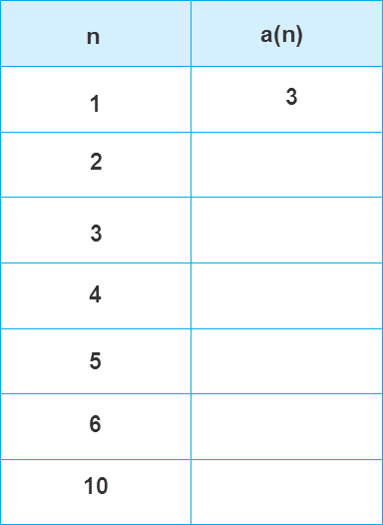 

4. What family of functions does a(n) belong? Is the graph continuous or discrete?

**Geometric Sequences:**

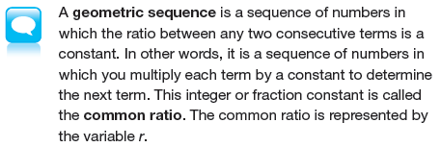

1. The sequence 3, 9, 27, 81… is geometric. What is the constant ratio, r?

2. The sequence above can be described by the function: .

a. What does the variable n represent in the sequence?

b. What does the variable g(n) represent in the sequence?

3. Use the function g(n) to complete the table and plot the points on the graph.

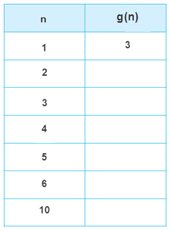 

4. What family of functions does g(n) belong? Is the graph continuous or discrete?

**Check for Understanding:**

1. Describe the sequence as Arithmetic, Geometric or Neither. State the value of d or r when appropriate.

a. 5, 7, 9, 11… b. 8, 4, 2, 1…

c. 4, 9, 16, 25… d. 44, 33, 22, 11…

2. An arithmetic sequence is defined by the function a(n) = 7 + 3(n-3). Use the function to list the first 5 terms of the sequence.

3. The first term of a geometric sequence is 4 and the constant ratio is -2. Find the first 5 terms of the sequence.